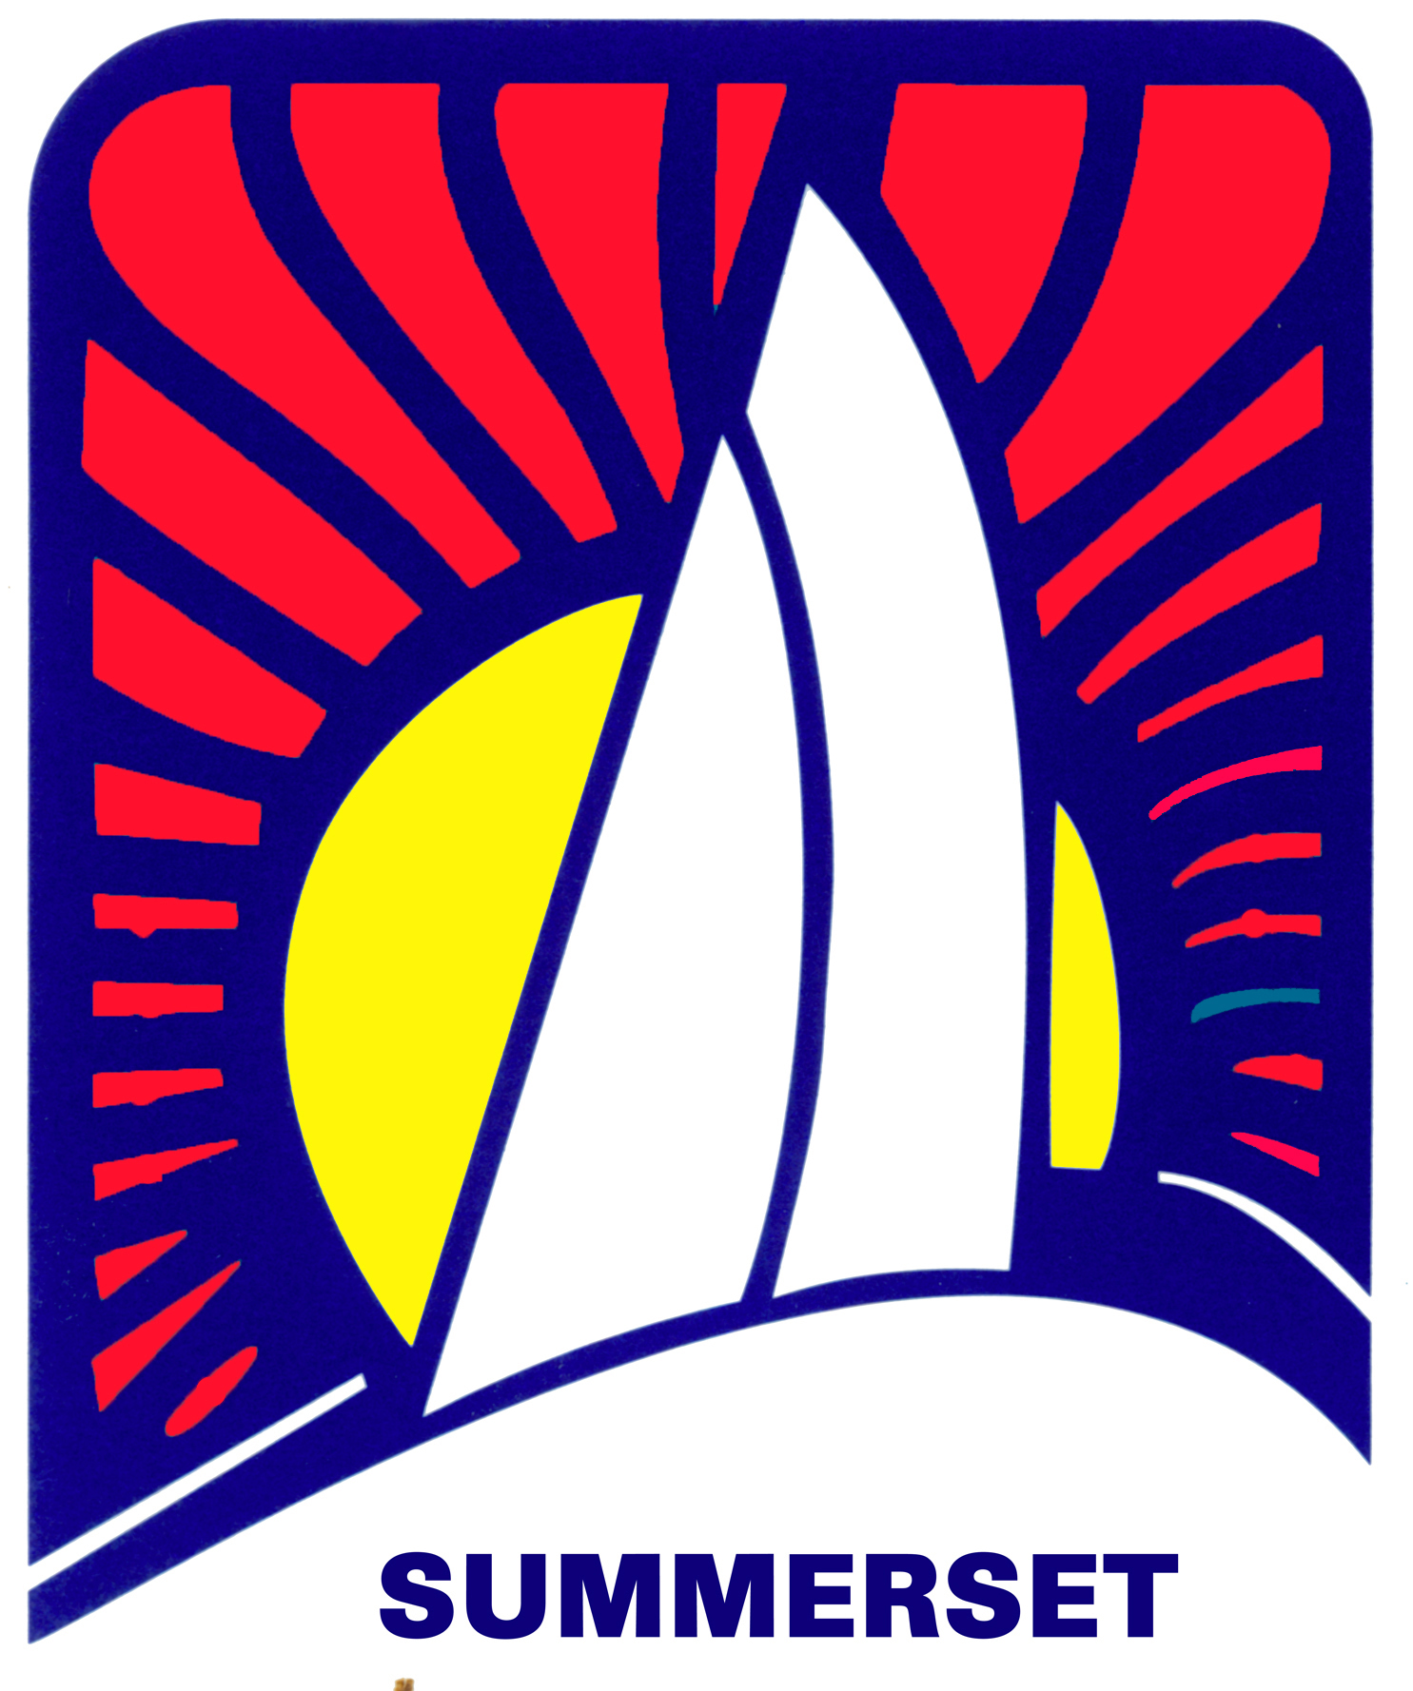
Contact: Beverly Duff
Rear Commodore of Summerset FOR IMMEDIATE RELEASE
Phone: 239-470-6612
E-Mail : ArgusGdn@comcast.net
Website: SummersetRegatta.com

Announcing the 56th Annual Summerset Regatta
Area Sailors to Enjoy the Return of Racing and Social Events the first weekend of October

Ft. Myers Beach, Florida (Sept 23, 2021) – This October, the Caloosahatchee Marching and Chowder Society (aka CMCS Sailing Club) will be hosting the 56th Annual Summerset Sailing Regatta in the Gulf of Mexico off of Ft. Myers Beach.

This beautiful display of sailboat racing and camaraderie will be held October 1st – 3rd and host sailors from Naples, Marco Island, Punta Gorda, Tampa as well as Cape Coral and Fort Myers. The net proceeds from the event will go towards funding youth sailing programs throughout these areas of west Florida.

Traditionally, four to five different classes of sailboats will do a series of Buoy Races on Saturday and a Distance Race on Sunday. Salty Sam's Marina, Pink Shell Marina, Moss Marine Marina have all opened their arms to welcome the many boats from out of town for the weekend full of parties and activities.

Schedule highlights:
- Friday Evening Oct 1 kicks off the weekend with a Skippers Meeting at Bonita Bills
- Buoy Racing starts on Saturday Morning at approximately 10:00am near the San Carlos Light. Spectators may be able to see the boats gathering and racing from many vantage points along the beach from the Pier to the Lani Kai and beyond.
- Saturday evening there are cocktails and dinner at the Original Shrimp Dock
- Racing continues Sunday morning with a distance race along Fort Myers Beach
- Sunday evening the weekend wraps up at the Original Shrimp Dock at Salty Sam's Marina with an Awards Dinner

For more information, or to register, please visit summersetregatta.com

###
Photographs available upon request and arrangements have been made for a press boat the morning of October 2nd and 3rd, 2021. Please contact Tom Conwell at 239-247-0713 for more information about joining the press boat.

About Caloosahatchee Marching & Chowder Society:
The Caloosahatchee Marching and Chowder Society (CMCS) was formed in 1970 in Fort Myers Beach, Florida and now boasts a vibrant membership of boaters throughout Southwest Florida. The purpose of the CMCS is to organize and promote sailing activities with an emphasis on offshore sailing, racing, and cruising. Multiple events are scheduled each year to include offshore cruises lasting ten days or more, coastal cruises lasting three to five days, plus a series of distance and buoy races in the Gulf of Mexico. The club’s signature event, the Summerset Regatta has run for 56 years, and proceeds go towards supporting youth sailing and education initiatives in Southwest Florida.

